Clayton DeSimone

Project Management

Assignment 8

2/26/2024

**Gantt Chart**

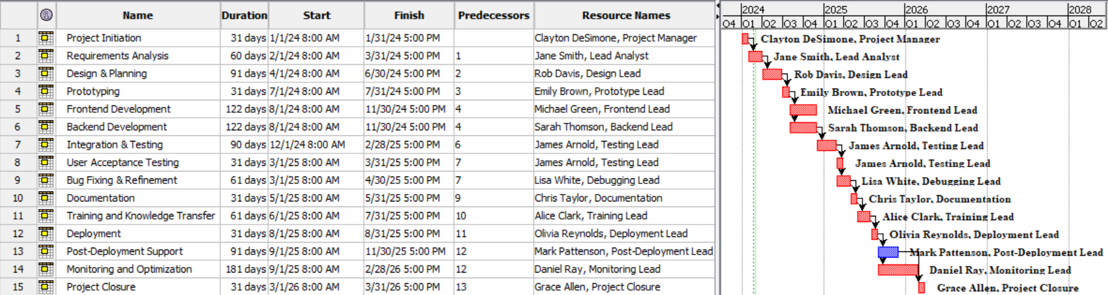

**PERT Diagram**

